CRUD Operations for 15 Main Business Processes
1. Inventory Management & Stock Control
Create - Add New Product to Inventory

Read - Check Stock Levels
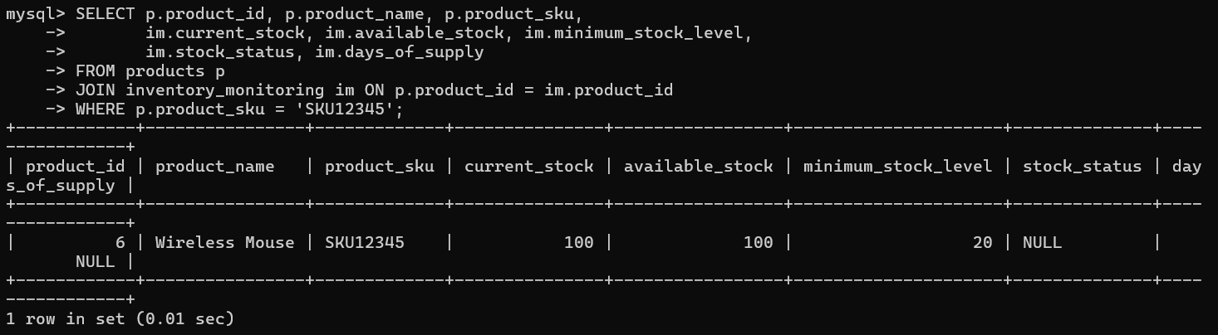

Update - Update Stock After Sale
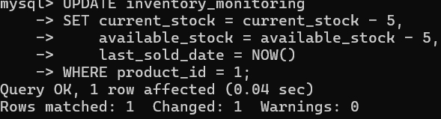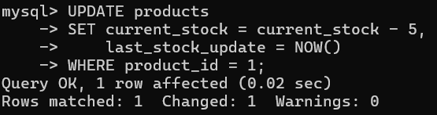

Delete - Remove Discontinued Product
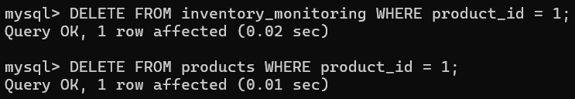
2. Purchase Order Processing
Create - New Purchase Order
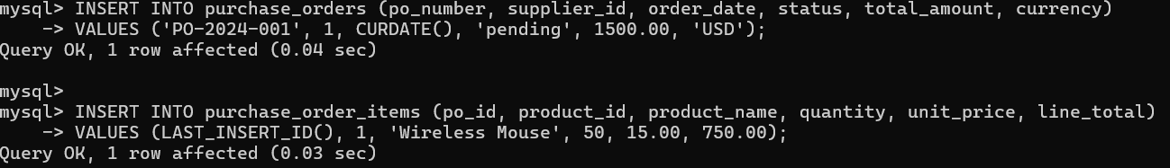

Read - View PO Details
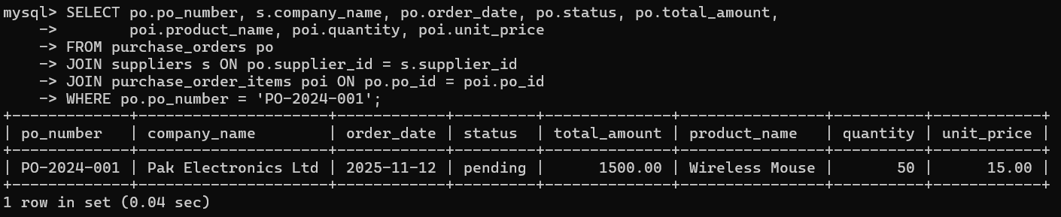

Update - Update PO Status
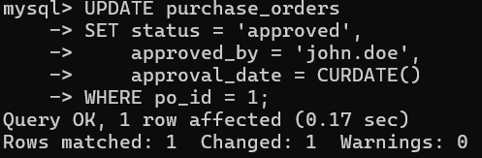

Delete - Cancel Purchase Order
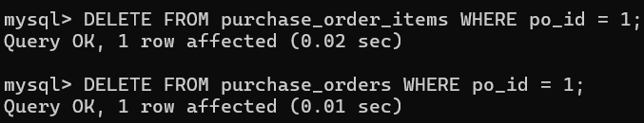

3. Warehouse & Storage Management
Create - Add New Shelf Location
Read - Check Warehouse Capacity
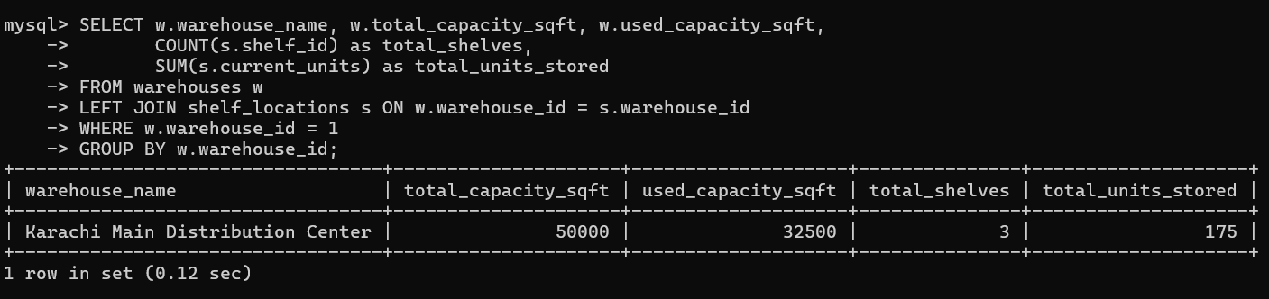
Update - Update Shelf Occupancy
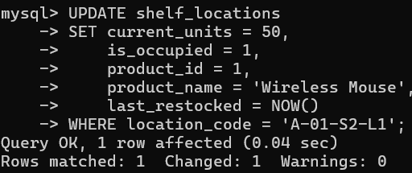
Delete - Remove Shelf Location
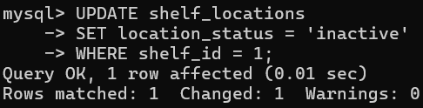

4. Order Fulfillment & Picking
Create - Generate Pick List
Read - View Active Pick Lists
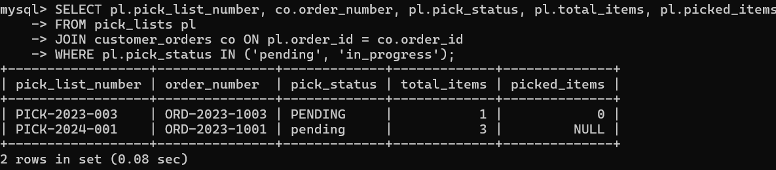

Update - Mark Item as Picked
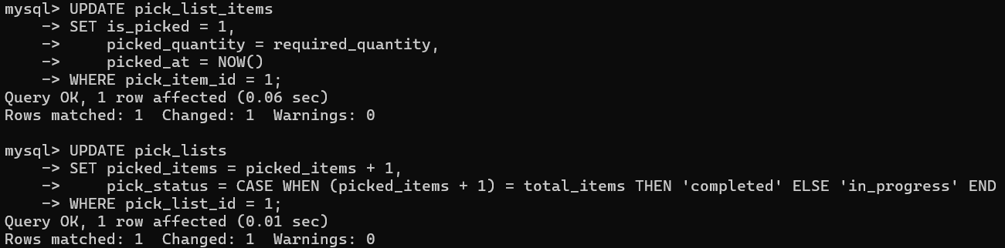

Delete - Remove Pick List Item

5. Quality Control & Inspection
Create - New Quality Check
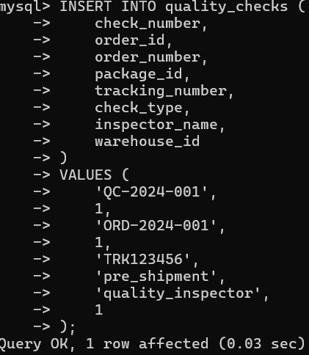

Read - Get Quality Check Results
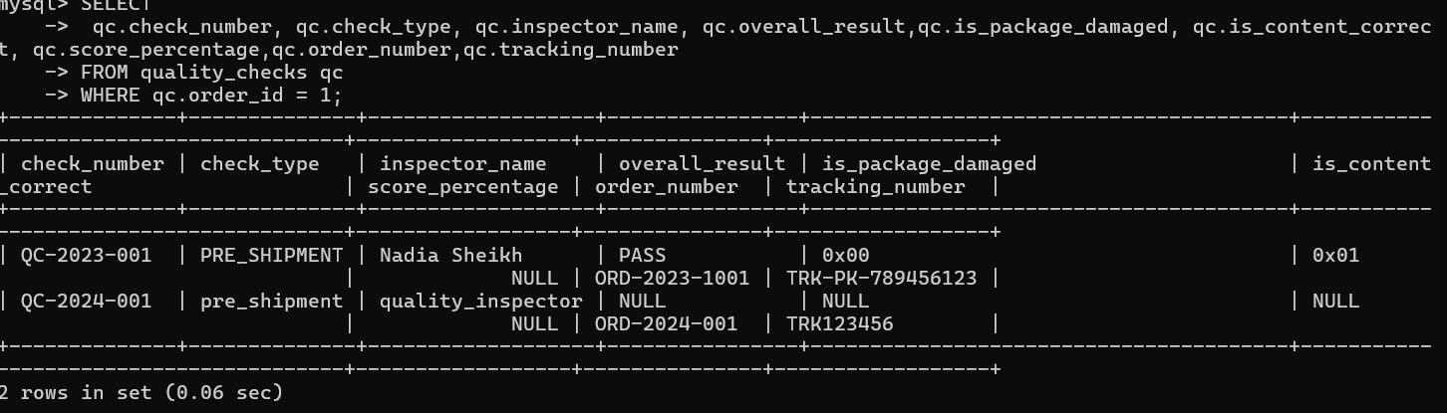

Update - Record Quality Check Results

Delete - Remove Quality Check

6. Shipping & Dispatch Management
Create - Create Shipment

Read - Track Shipment Status
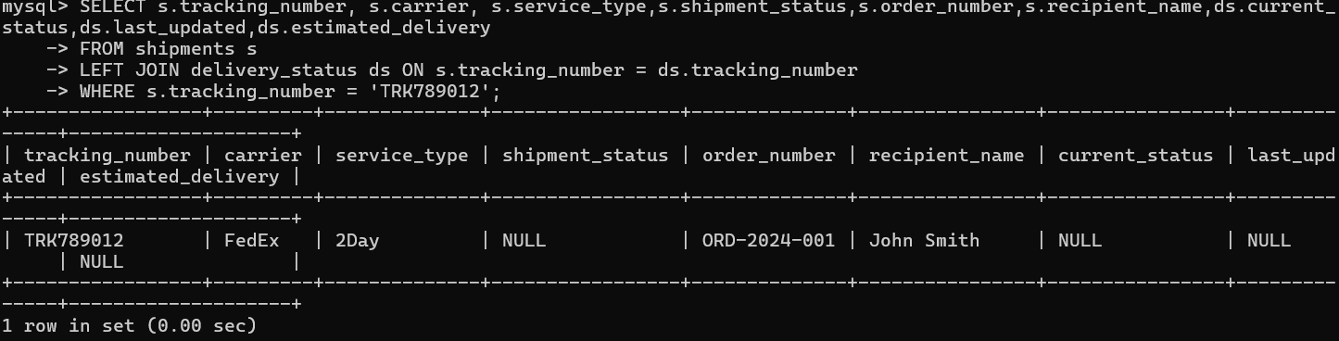

Update - Update Shipment Status
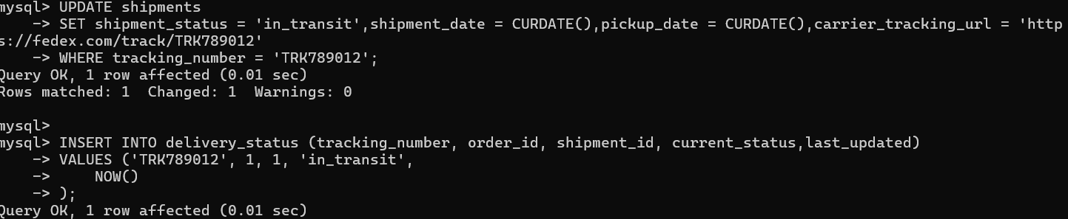

Delete - Cancel Shipment
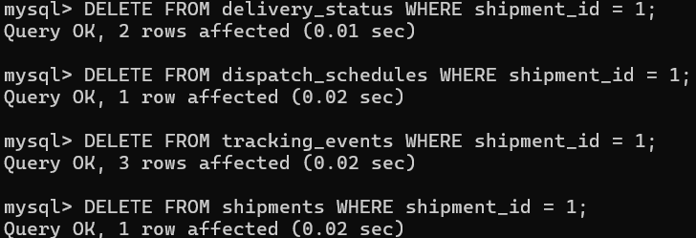

7. Delivery & Tracking Management
Create - Record Delivery Status

Read - Get Delivery Timeline
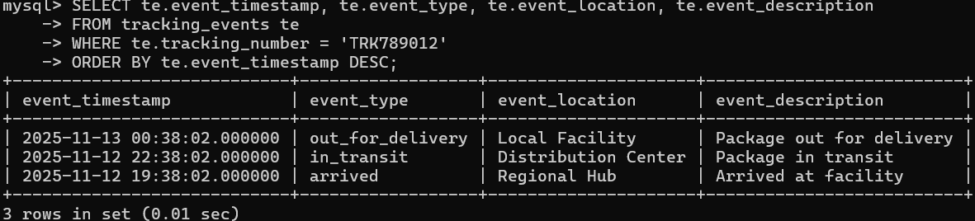

Update - Mark as Delivered
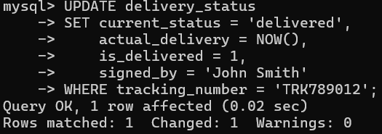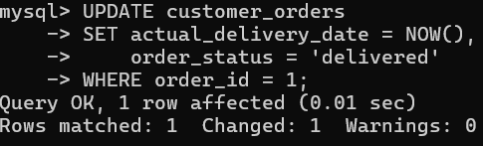

Delete - Remove Tracking Event

8. Returns Processing
Create - Initiate Return Request
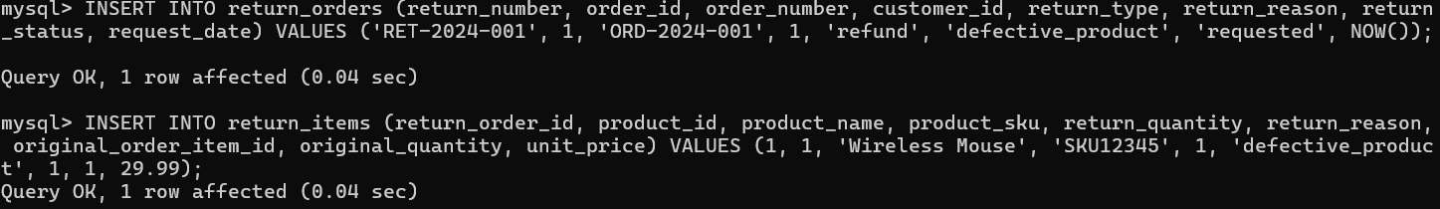
Read - View Return Requests
Update - Process the return
Delete - Remove return if needed

9. Supplier & Contract Management
Create - Add New Supplier

Read - View Supplier Performance
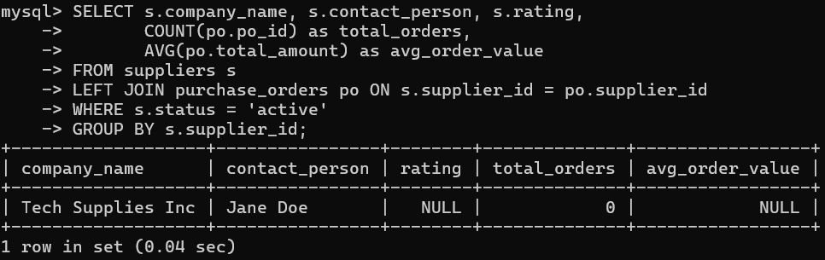

Update - Update Supplier Rating
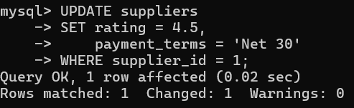

Delete - Deactivate Supplier
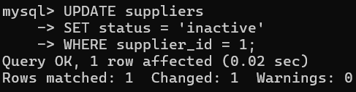

10. Demand Forecasting & Planning
Create - Generate Demand Forecast

Read - Get Forecast Data
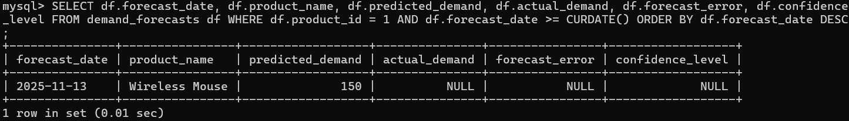

Update - Update Forecast with Actuals

Delete - Remove Old Forecast

11. Goods Receipt & Inspection
Create - Record Goods Receipt

Read - View Receipt Details
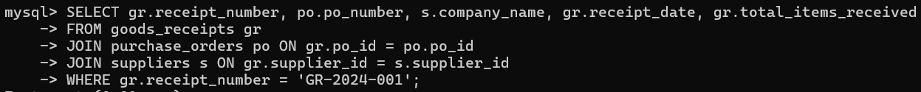

Update - Update Receipt Status
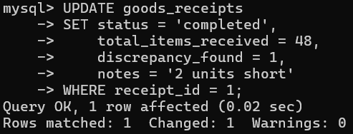

Delete - Remove Receipt Record
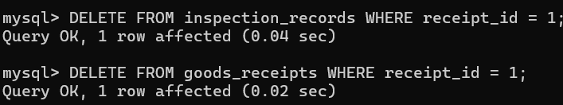

12. Package & Shipment Preparation
Create - Create Package
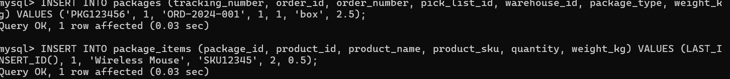

Read - View Package Contents
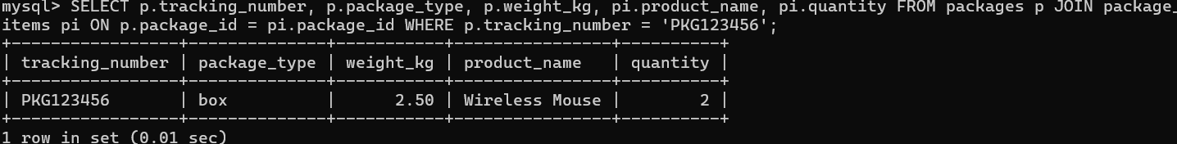

Update - Update Package Status

Delete - Remove Package

13. Inventory Reconciliation
Create - Start Reconciliation Report
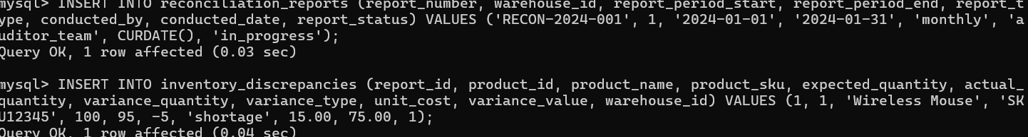

Read - View Reconciliation Results

Update - Resolve Discrepancy
Delete - Remove Reconciliation Report

14. Customer Order Management
Create - Create Customer Order
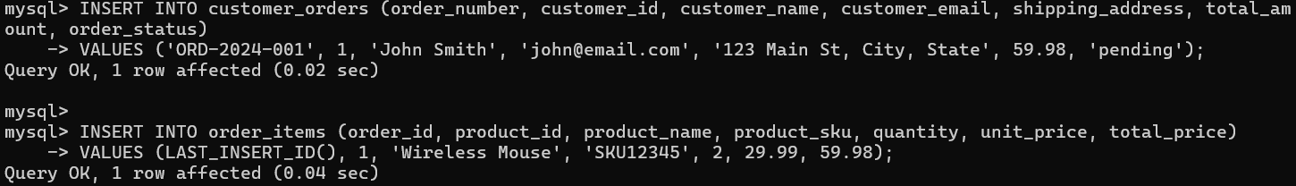

Read - View Customer Order History
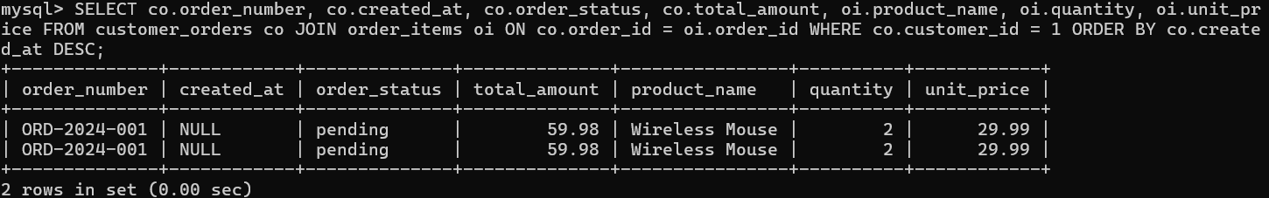

Update - Update Order Status

Delete - Cancel Order

15. Exception & Resolution Management
Create - Log Delivery Exception

Read - View Open Exceptions
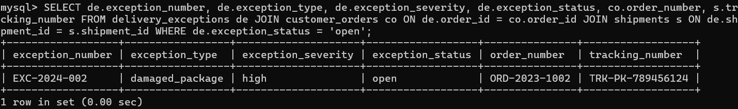

Update - Resolve Exception
Delete - Remove Exception Record

